EE 465 Lab Report
Lab 3 – Standard Cell Characterization
Team – Anh Q. Ho; Aaron Pederson
Section A – Monday 4:00pm

Introduction
In this lab, students are to continue from their lab 2 experiment and and perform characterization of the DFF.
- Get to know about standard cell library
- Learn simulation in analog environment
- Perform cell characterization and analysis
Standard cell characterization means creating a set of models that accurately and efficiently represents the behavior (e.g., delay, timing constraints, input capacitance, power) of a standard cell. These models enable the cell to be effectively useful at earlier design stages (e.g., functional design, logic design). Without the models, very time-consuming operations like timing simulation and power extraction have to be repeatedly performed. Students are to perform characterization of the DFF of previous lab and compare the cell-rise(delay_template_7x7) and rise_transition(delay_template_7x7) with seven different values of output net capacitance and create a trend charts for both delay and rise transition of both table vs output net capacitance.

Circuit Layout requirement:
- Power Supply: 1.3 V
- Maximum metal layers: 4

In this lab, students will also have a little competition among the lab section to to determine the group with the smallest cell_rise*chip area.

Result
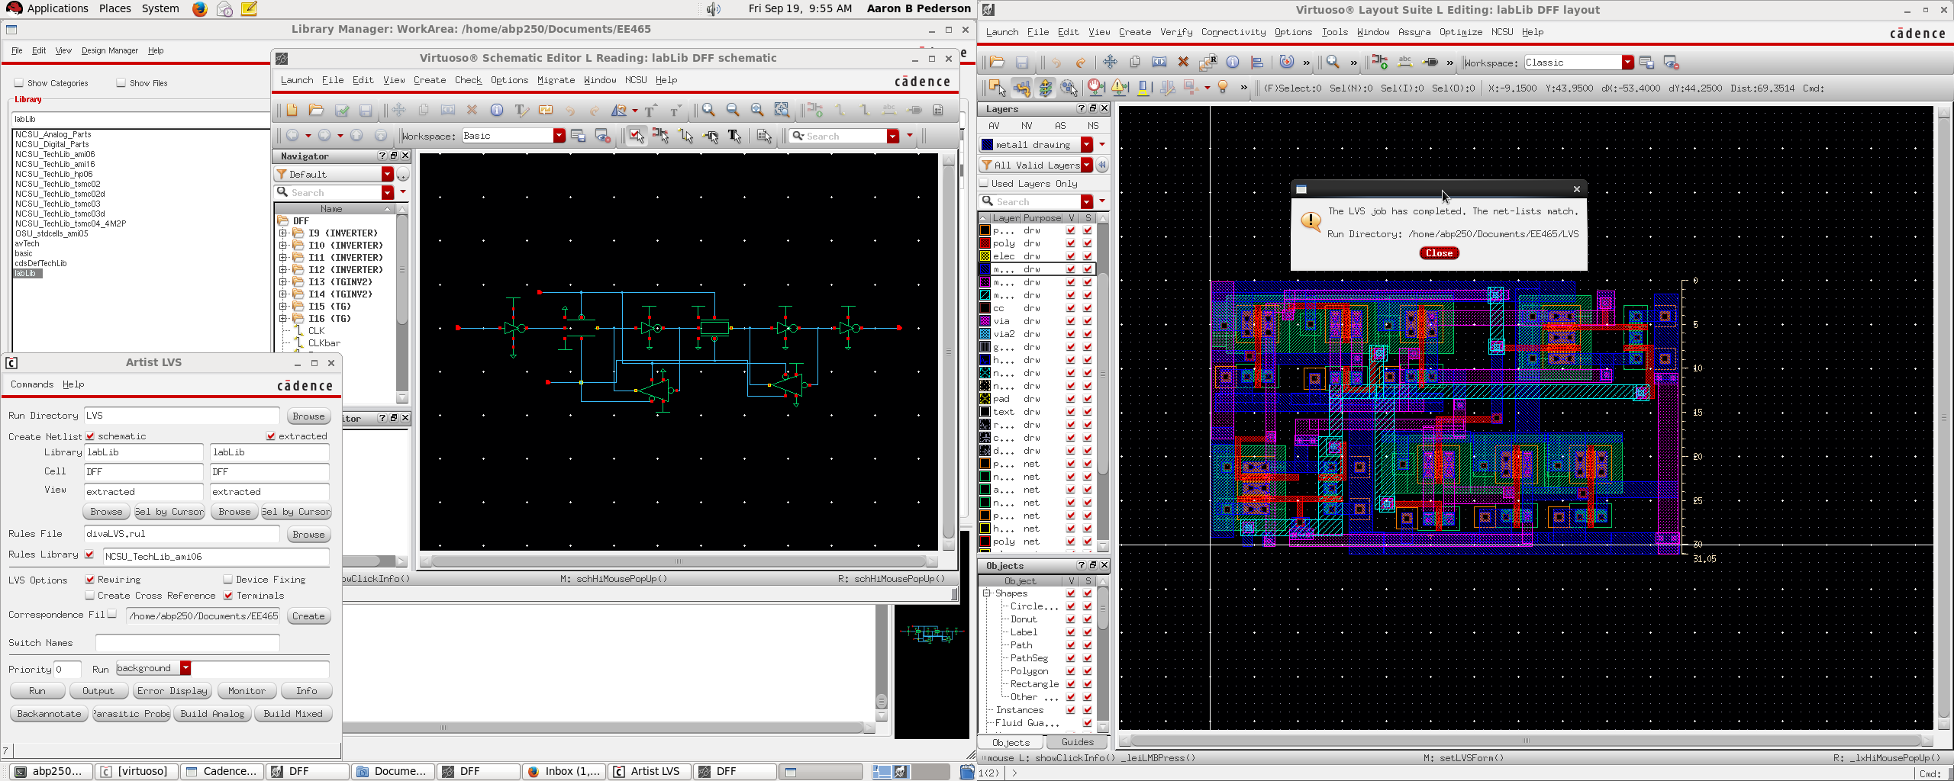
Figure 1-LVS result.

Layout Area: 30.9um x 50.85um
Proof of the Layout Area
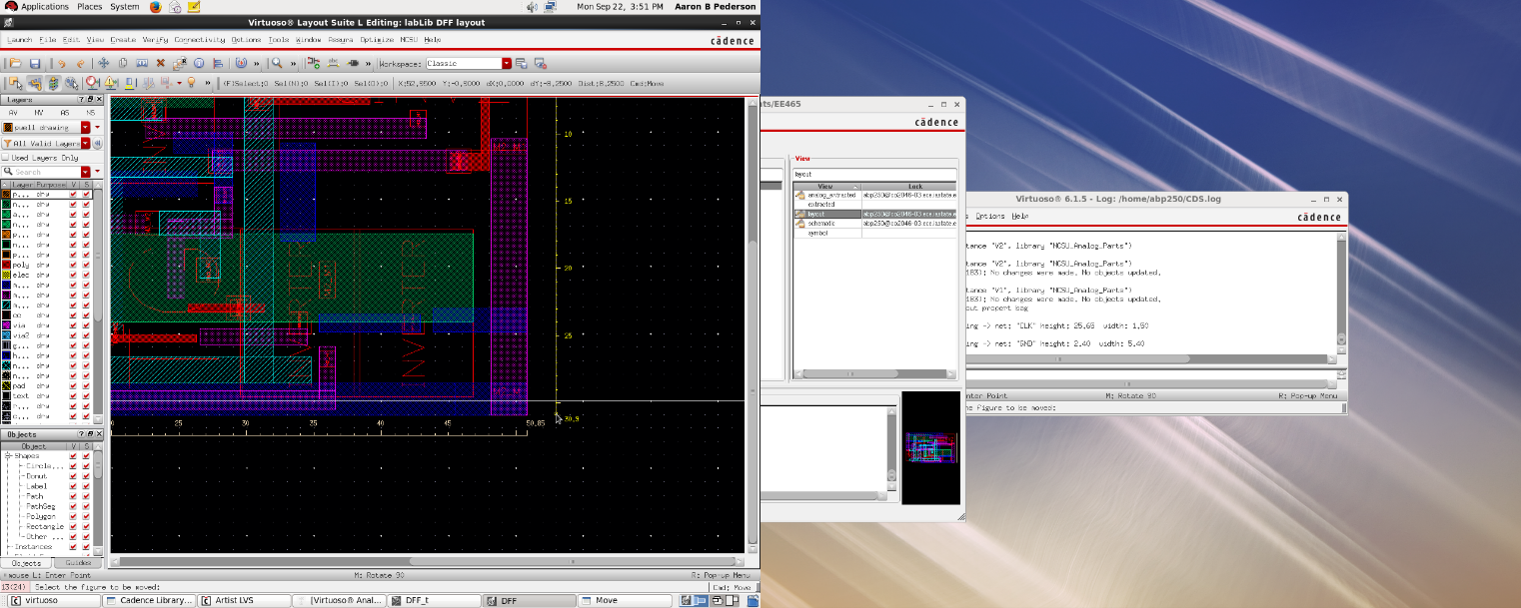
Figure 2-Layout dimensions.
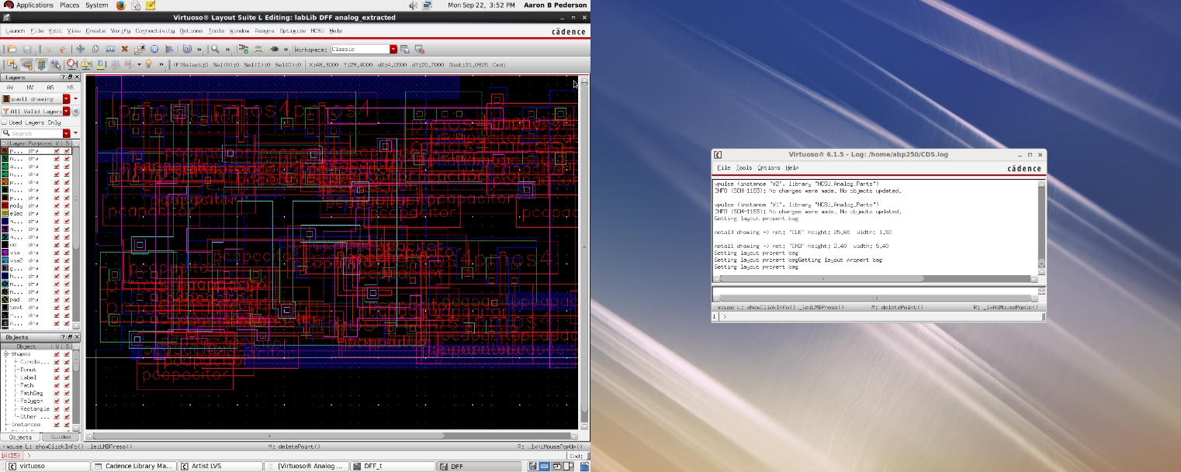
Figure 3-Extracted analog with parasitic capacitors.
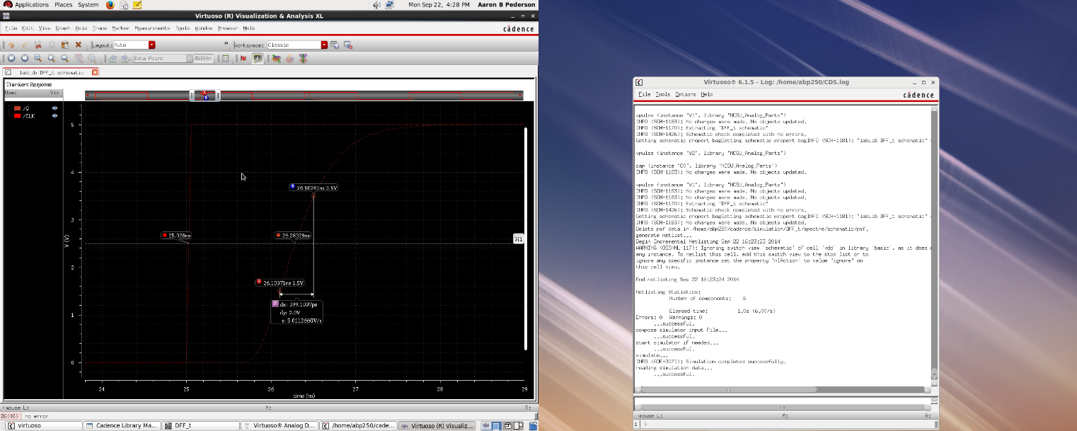
Figure 4-Method of determining the rise delay and rise transition.

- The rise delay is determined by the difference between output Q and Clock signal at 50% input voltage.
- The rise transition is determined by the difference of the output Q at 70% and 30% of the input voltage.

Figure 5-Data gathered from DFF.

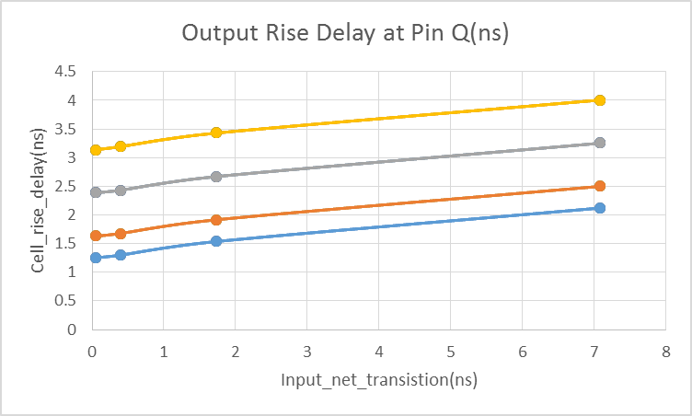
Figure 6-Output Rise Delay at Pin Q (ns).

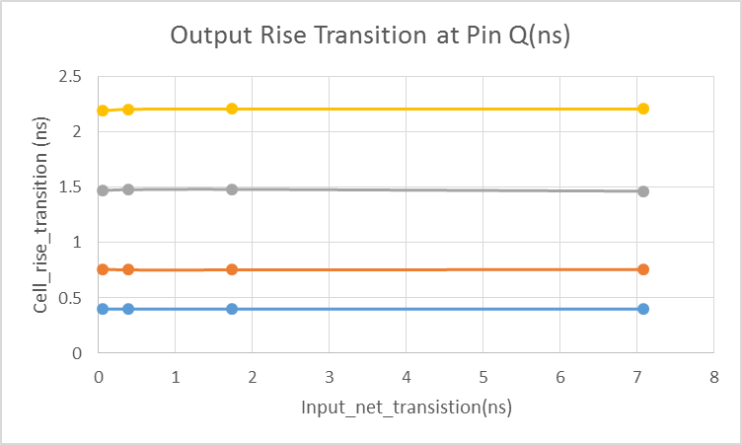
Figure 7-Output rise transition at Pin Q (ns).

Conclusion
As a group, the lab went fairly well. The most important part of this lab is to be able to get the LVS match. Otherwise, it would not be able to create the analog_extracted. The group had a problem with the LVS and found out that a connection between an outputs of a transmission gate were not connected to the input of an inverter thus given a lot of issues.

